# CTGuard Mobile Application

Project Documentation Submitted

To the Faculty of School of

Computing and Information Technologies

Of

Asia Pacific College

In Partial Fulfillment of the Requirements for the subject

Applied Projects 2

By

Barriga, Jacques Vincent

Catuncan, Franz Iljah  
De Mesa, Paul Franzchel

Dizon, Dan Patrick

Maraya, Lorina

Mojica, Albert John

Pilares, Dwight Stephen Paolo

Table of Contents

CTGuard Mobile Application 1

Executive Summary 3

List of Figures, List of Tables, List of Notations 4

I. Introduction 5

1.1 Project Context 5

1.2 Purpose and Description 5

1.3 Objectives 5

1.4 Scope and Limitations 5

II. Review of Related Literature/Systems 5

III. Technical Background 5

IV. Methodology, Results and Discussion 5

4.1 Requirements Analysis 5

4.2 Requirements Documentation 5

4.3 Design of Software, Systems, Product, and/or Processes 5

4.4 Development and Testing, where applicable 5

4.5 Description of the Prototype, where applicable 5

4.6 Implementation Plan (Infrastructure/Deployment) where needed 5

4.7 Implementation Results, where applicable 5

4.8 Include discussion on conceptual design / system architecture/ block diagrams and algorithms 5

V. Conclusions and Recommendations 5

VI. Appendices 5

# Executive Summary

# List of Figures, List of Tables, List of Notations

# Introduction

## Project Context

## CTGuard Mobile Application is a safety commuting application which can help passengers immediately report abusive PUV Drivers they may encounter. Summary features of the application includes QR Code Scanning, Live tracking and route analysis, Transport identification, Pick-up and Destination Point Analysis, Distress feature and Complaint function.

## Purpose and Description

CTGuard is a mobile application with a purpose of lessening criminal incidents that involve public utility drivers particularly of taxis. Through the app, users can alert authorities of imminent distress with a push of a button. The app also allows users to stay connected with close friends and relatives through its live tracking module. With CTGuard, commuters will feel safe and secure as they commute around the city.

## Objectives

**General Objective**

* CTGuard Mobile Application is a safety commuting application which can help passengers immediately report abusive PUV Drivers they may encounter

**Specific Objectives**

* To enable passengers to report abusive PUV Drivers
* To enable passengers to report violations they have encountered
* Give commuters ability to inform their desired contacts where they are going, what taxi they are riding and to track their current location.
* To let commuters experience a safer and more efficient travel experience

## Scope and Limitations

**Scope of Initial Release:**

* QR Code Scanner – to ensure the safety and sense of security of our commuters, the application will be equipped with a QR code scanning function to fetch identifying details of the vehicle the commuter is in.
* Automatic loading of local contacts – with regards to convenience, the application will do the task of fetching the commuter’s contacts for him/her.
* Google Maps Navigation – the application will help the commuter pick a destination as well as know what routes to be taken so as to avoid being taken to unfamiliar places by potentially abusive drivers.
* Distress Feature – with the simple push of a button, the application will contact 911 as well as the commuter’s selected contacts and will state that he/she is in danger accompanied by his/her current coordinates that constantly update
* Complaint function – should the commuter’s trip involve anything unpleasant with regards to the driver’s conduct or that of another encountered along the way, he/she can file a complaint with a single push that will be sent directly to the proper authorities (LTFRB)

**Constraints and Limitations**

* Mobile Data – Mobile Data is dependent on Data subscription and the Telco’s Data speed
* SMS transmission – SMS delay is dependent to the telco’s signal availability in the area
* Sound Quality of Calls – Quality of Calls is dependent to the Mobile Device’s Signal strength
* Video and/or Audio quality – Quality is dependent to the mobile device’s Video and audio recording capabilities
* App response – performance is dependent on the mobile device’s specifications (i.e., processors, RAM) and operating system
* GPS tagging accuracy – accuracy is dependent on mobile device’s location and proximity from the nearest satellite
* API to Database Communication – Transmission speed between the API and Database cannot be controlled.

# Review of Related Literature/Systems

# Technical Background

* Include in-depth discussion on relevant technical aspects of the project

# Methodology, Results and Discussion

## Requirements Analysis

## Requirements Documentation

## Development and Testing, where applicable

## Description of the Prototype

**Register**

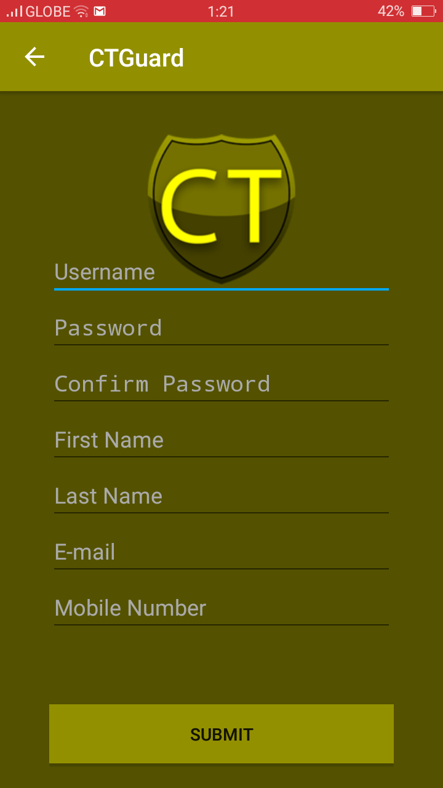

**Login**

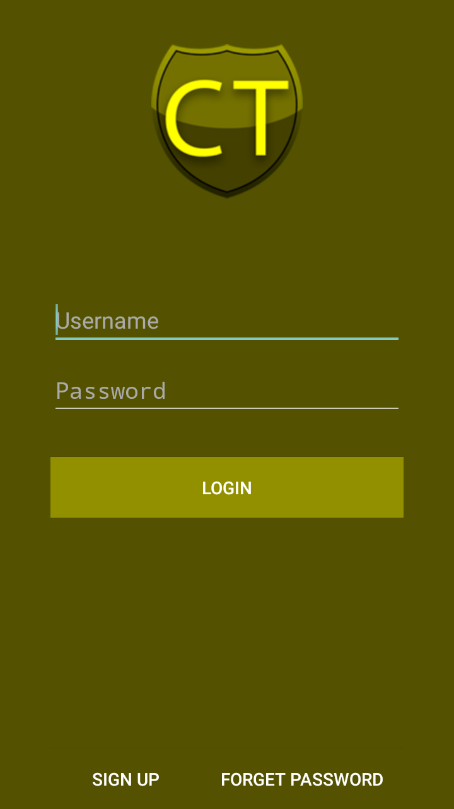

**Home Page upon Login**

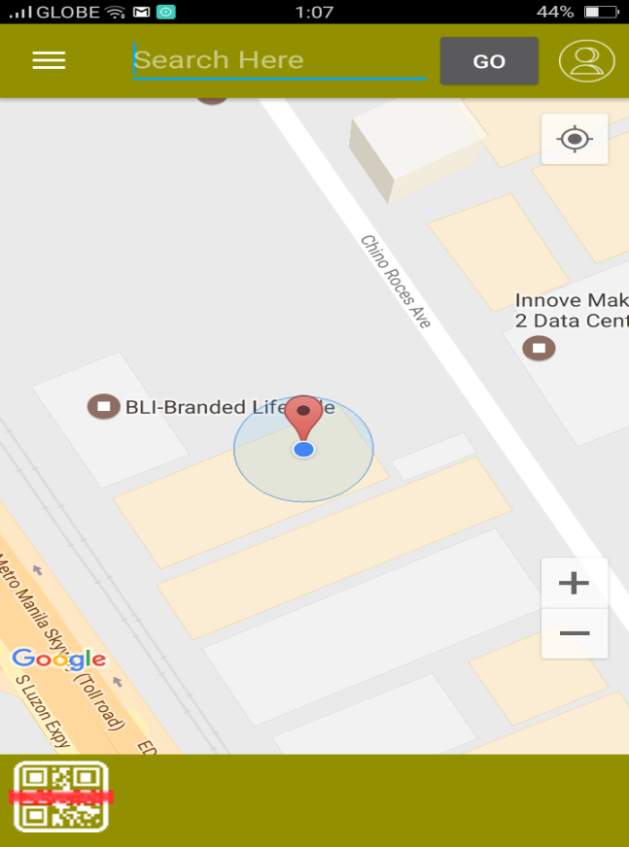

**Homepage after scanning or set destination**

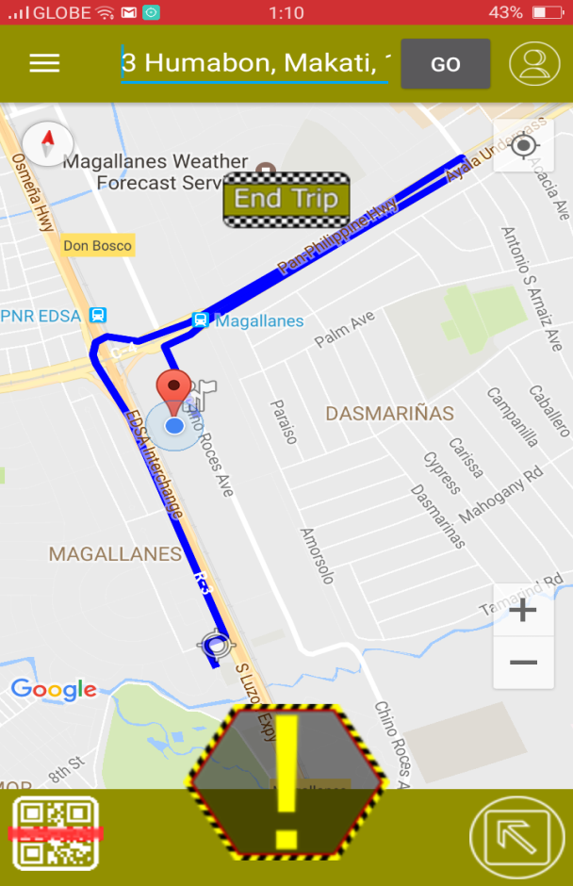

**Distress Button**

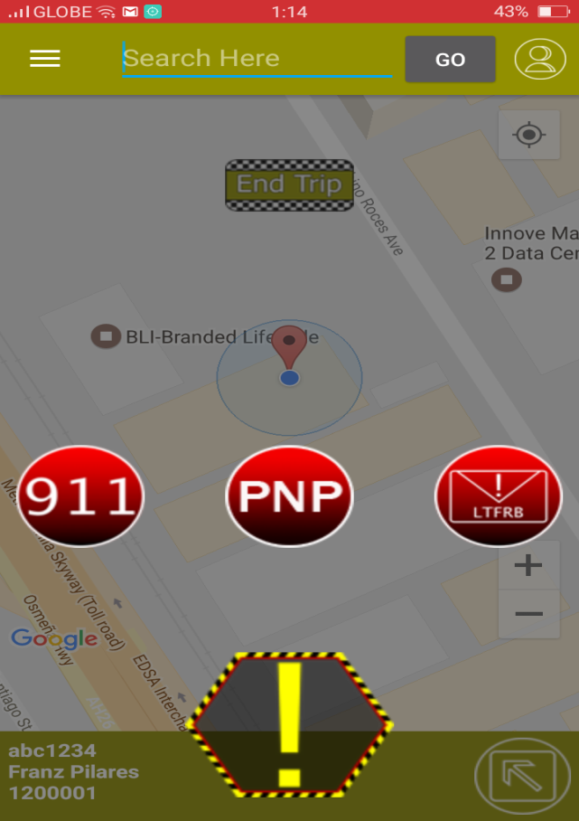

## Implementation Plan (Infrastructure/Deployment) where needed

## Implementation Results, where applicable

## 4.7 Include discussion on conceptual design / system architecture/ block diagrams and algorithms

# Conclusions and Recommendations

# Appendices

May include the following:

- Relevant Source Code

- Evaluation Tool or Test Documents

- Sample input/output/Reports

- Users Guide

- Process/Data/Information Flow

- Screen layouts

- Test Results

- Sample Generated Outputs

- Pictures showcasing the data gathering, investigation done (e.g. floor plan, layout, building, etc.)

- One-Page Curriculum Vitae per team member